For simulating your database, use <https://sqliteonline.com/>

For learning about SQL syntax, use <https://www.w3schools.com/sql/>

Creating Tables using SQL

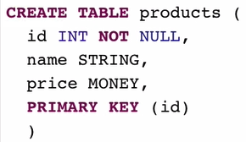

* Primary Key means that key value won’t be repeated.
* NOT NULL means that the field won’t be empty.

INSERT values to an SQL table: two ways

First one



Second one



Seeing table (Reading everything in the table)





Viewing particular columns and corresponding data



Viewing particular rows (Using WHERE keyword)



UPDATE table values

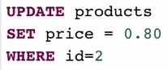

Adding a column in SQL



Deleting rows in SQL



* Deletes every row in your table



* Deletes the row with id 2

SQL Foreign Key

* <https://www.w3schools.com/sql/sql_foreignkey.asp#:~:text=A%20FOREIGN%20KEY%20is%20a,the%20referenced%20or%20parent%20table>.
* 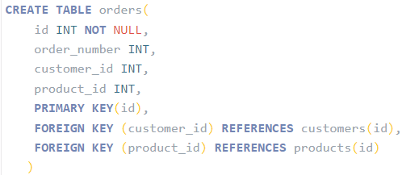
* is a field (or collection of fields) in one table, that refers to the PRIMARY KEY in another table.
* The table with the foreign key is called the child table, and the table with the primary key is called the referenced or parent table.
* The FOREIGN KEY constraint prevents invalid data from being inserted into the foreign key column, because it has to be one of the values contained in the parent table.

INNER JOIN

* 
* 
* It selects records that have matching values in both tables